R PROGRAMMING

EXPERIMENT-1
ADDITION:
AIM:
To prove the program for addition using R-tool.
PROGRAM:
num1=as.integer(readline(prompt = "enter the first number:"))
num2=as.integer(readline(prompt = "enter the second number:"))
num3=num1+num2
print(num3)
OUTPUT:
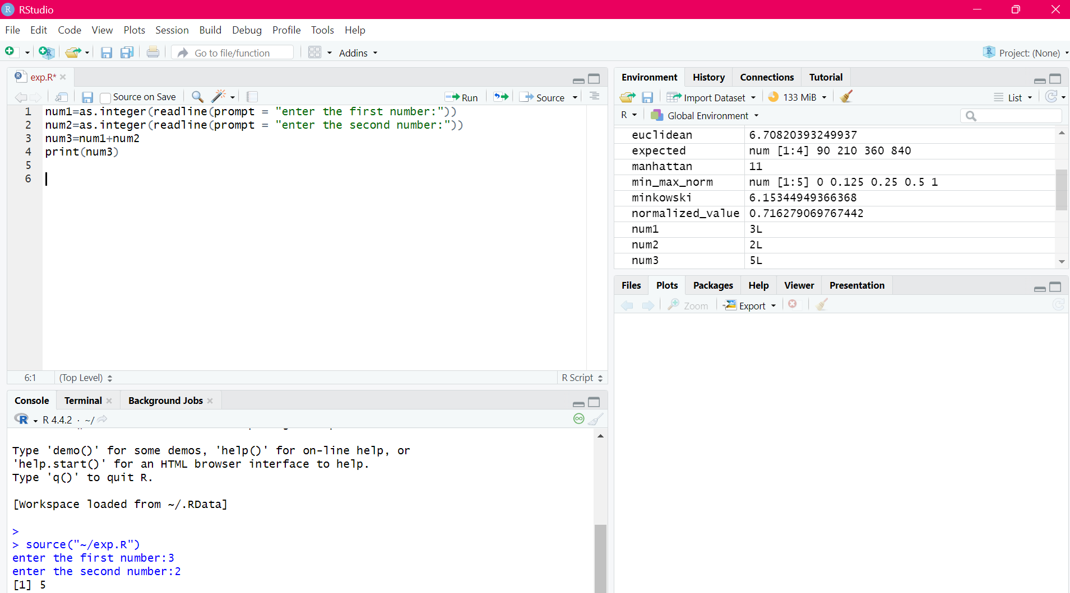

RESULT:
Thus the basic program addition is executed successfully.

EXPERIMENT-2
SUBTRACTION:
AIM:
To prove the program for subtraction using R-tool.

PROGRAM:
num1=as.integer(readline(prompt = "enter the first number:"))
num2=as.integer(readline(prompt = "enter the second number:"))
num3=num1-num2
print(num3)
OUTPUT:
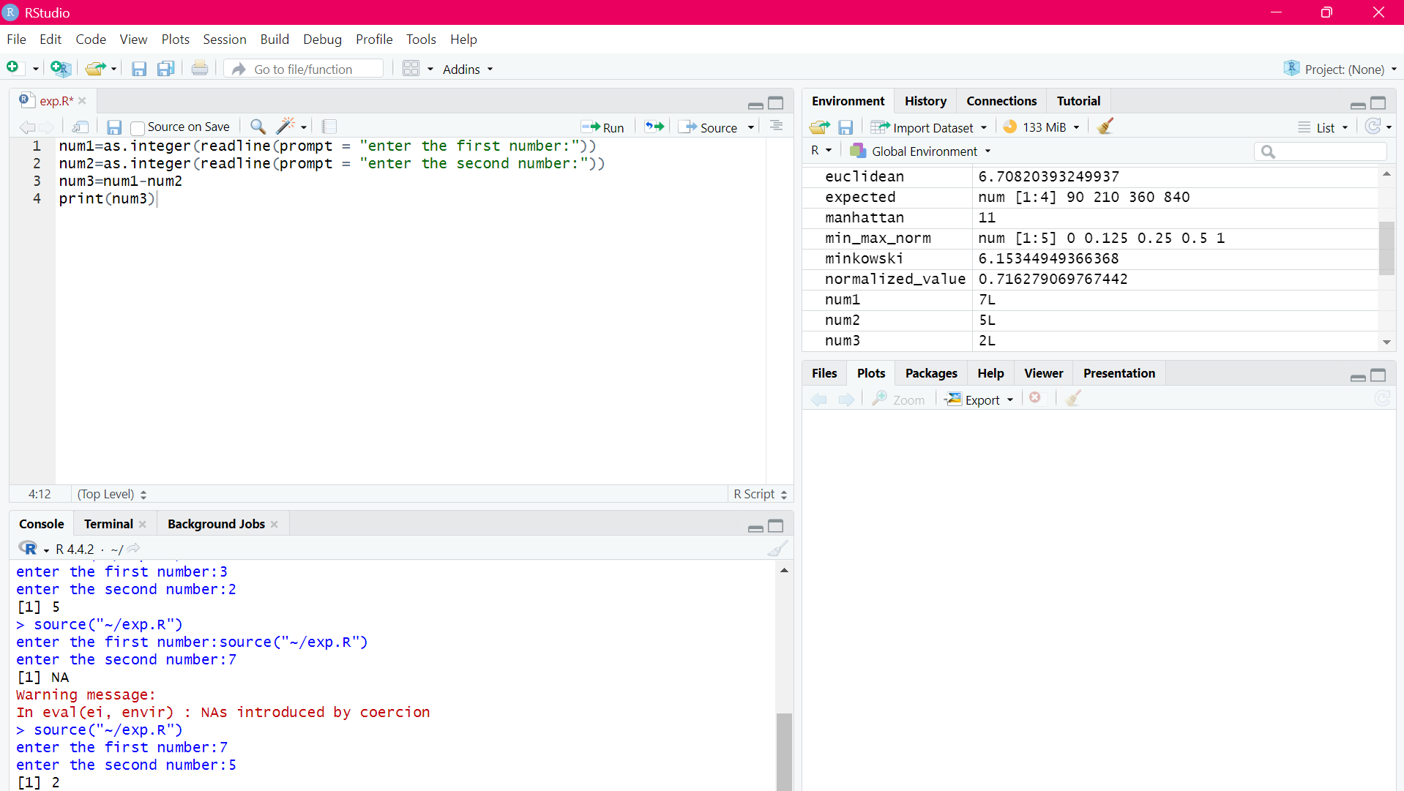
RESULT:
Thus, the basic program subtraction is executed successfully.

EXPERIMENT-3
MULTIPLICATION:
AIM:
To prove the program for multiplication using R-tool.
PROGRAM:
num1=as.integer(readline(prompt = "enter the first number:"))
num2=as.integer(readline(prompt = "enter the second number:"))
num3=num1*num2
print(num3)
OUTPUT:
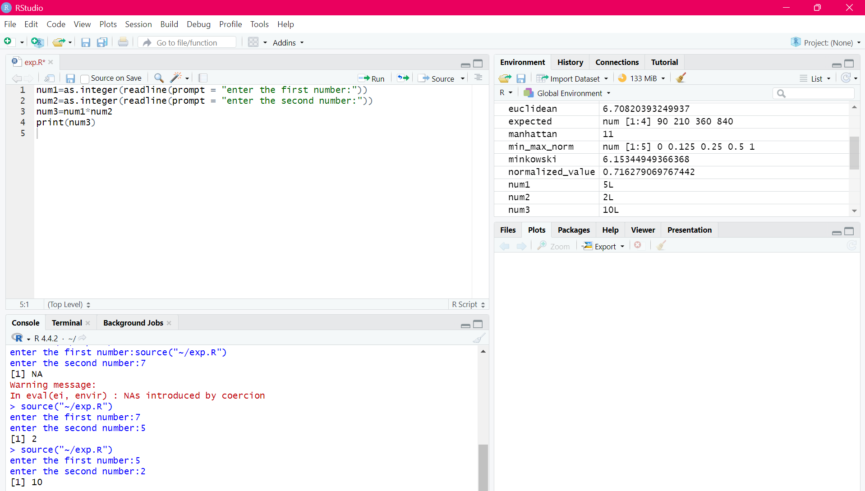
RESULT:
Thus, the basic program multiplication is executed successfully.

EXPERIMENT-4
DIVISION:
AIM:
To prove the program for division using R-tool.
PROGRAM:
num1=as.integer(readline(prompt = "enter the first number:"))
num2=as.integer(readline(prompt = "enter the second number:"))
num3=num1/num2
print(num3)
OUTPUT:
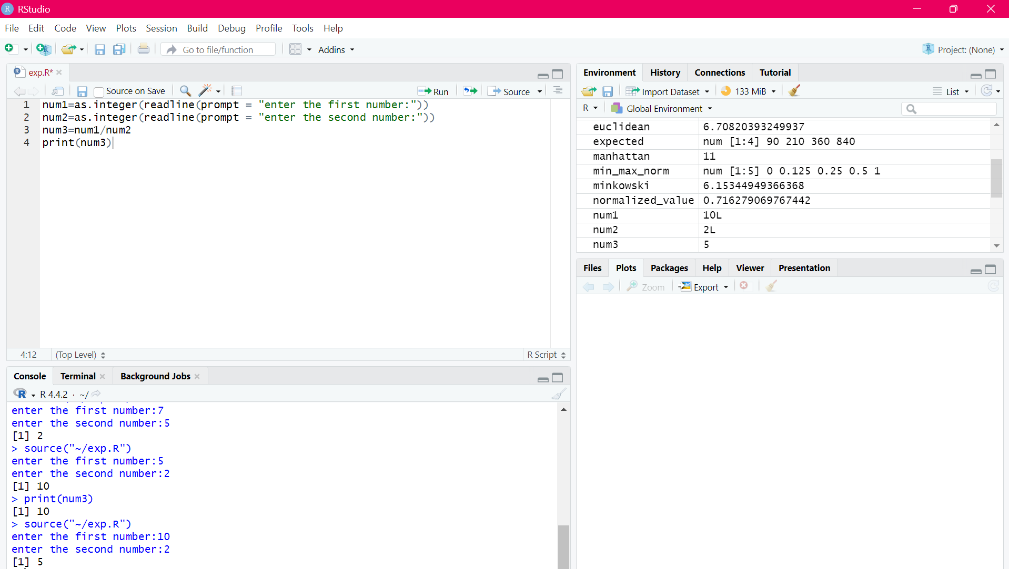

RESULT:
Thus, the basic program division was executed successfully.

EXPERIMENT-5
ODD OR EVEN:
AIM:
To write the program for odd or even using R-tool.
PROGRAM:
num=as.integer(readline(prompt="enter a number:"))
if((num%%2)==0)
{
print("number is a even")
}else{
print("number is odd")
}
OUTPUT:
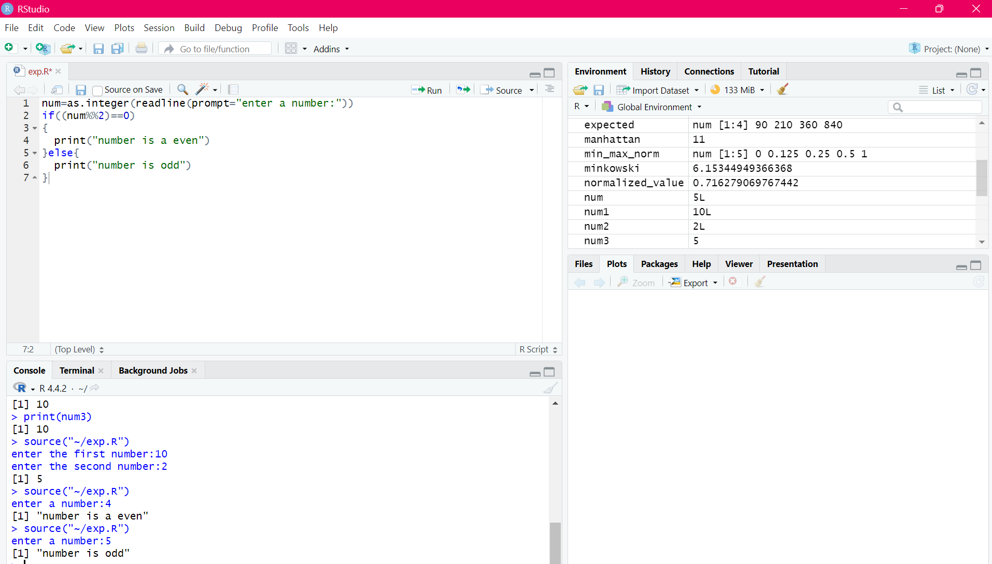
RESULT:

Thus, the basic program odd or even was executed successfully.

EXPERIMENT-6
MEAN,MEDIAN,MODE:
AIM:
To write the program for mean,median,mode.
PROGRAM:
MEAN
names<-c("siri","mahi","chiru")
age<-c(23,24,25)
marks<-c(88,78,25)
df<-data.frame(names,age,marks)
mean(df $age)
write.csv(df,"datafr.csv")
MEDIAN
names<-c("siri","mahi","chiru")
age<-c(23,24,25)
marks<-c(88,78,25)
df<-data.frame(names,age,marks)
median(df $age)
write.csv(df,"datafr.csv")

MODE
names<-c("siri","mahi","chiru")
age<-c(23,24,25)
marks<-c(88,78,25)
df<-data.frame(names,age,marks)
mode(df $age)
write.csv(df,"datafr.csv")
OUTPUT:
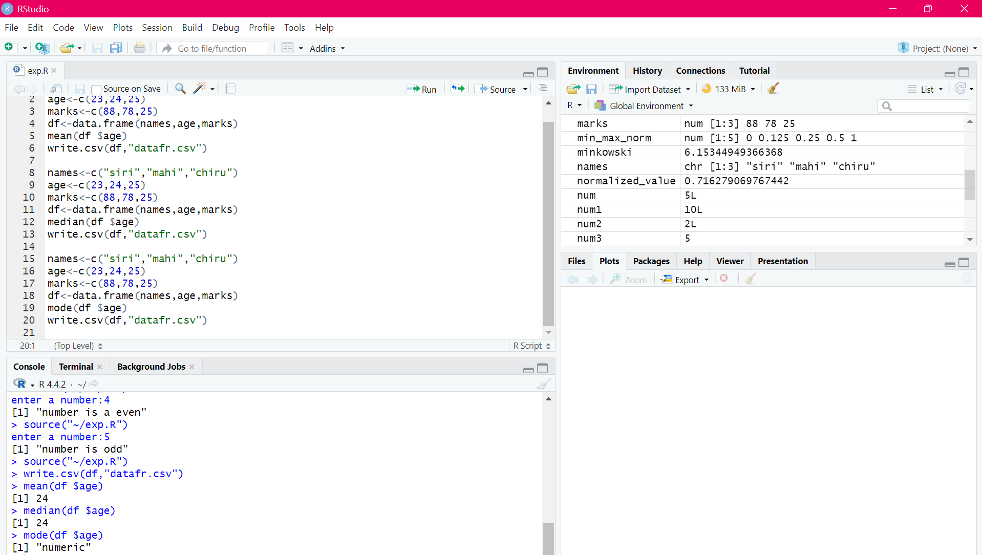RESULT:
Thus the central tendency and measure of dispersion is executed successfully.

EXPERIMENT-7
SUMMARY:
AIM:
To write the program for summary using R-tool.
PROGRAM:
names<-c("siri","mahi","chiru")
age<-c(23,24,25)
marks<-c(88,78,25)
df<-data.frame(names,age,marks)
summary(df $age)
write.csv(df,"datafr.csv")
OUTPUT:
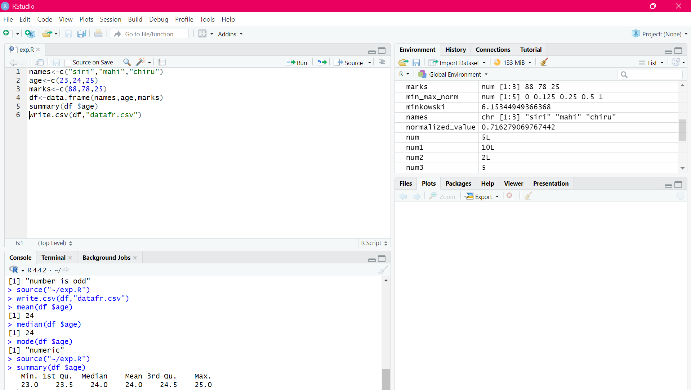
RESULT:
Thus, the central tendancy and measure of dispersion is executed successfully.

EXPERIMENT-8
GREATER AMONG THREE NUMBERS:
AIM:
To write the program for the greatest among three numbers.
PROGRAM:
x <- as.integer(readline(prompt = "Enter first number :"))
y <- as.integer(readline(prompt = "Enter second number :"))
z <- as.integer(readline(prompt = "Enter third number :"))

if (x > y && x > z) {
print(paste("Greatest is :", x))
} else if (y > z) {
print(paste("Greatest is :", y))
} else{
print(paste("Greatest is :", z))
}
OUTPUT:
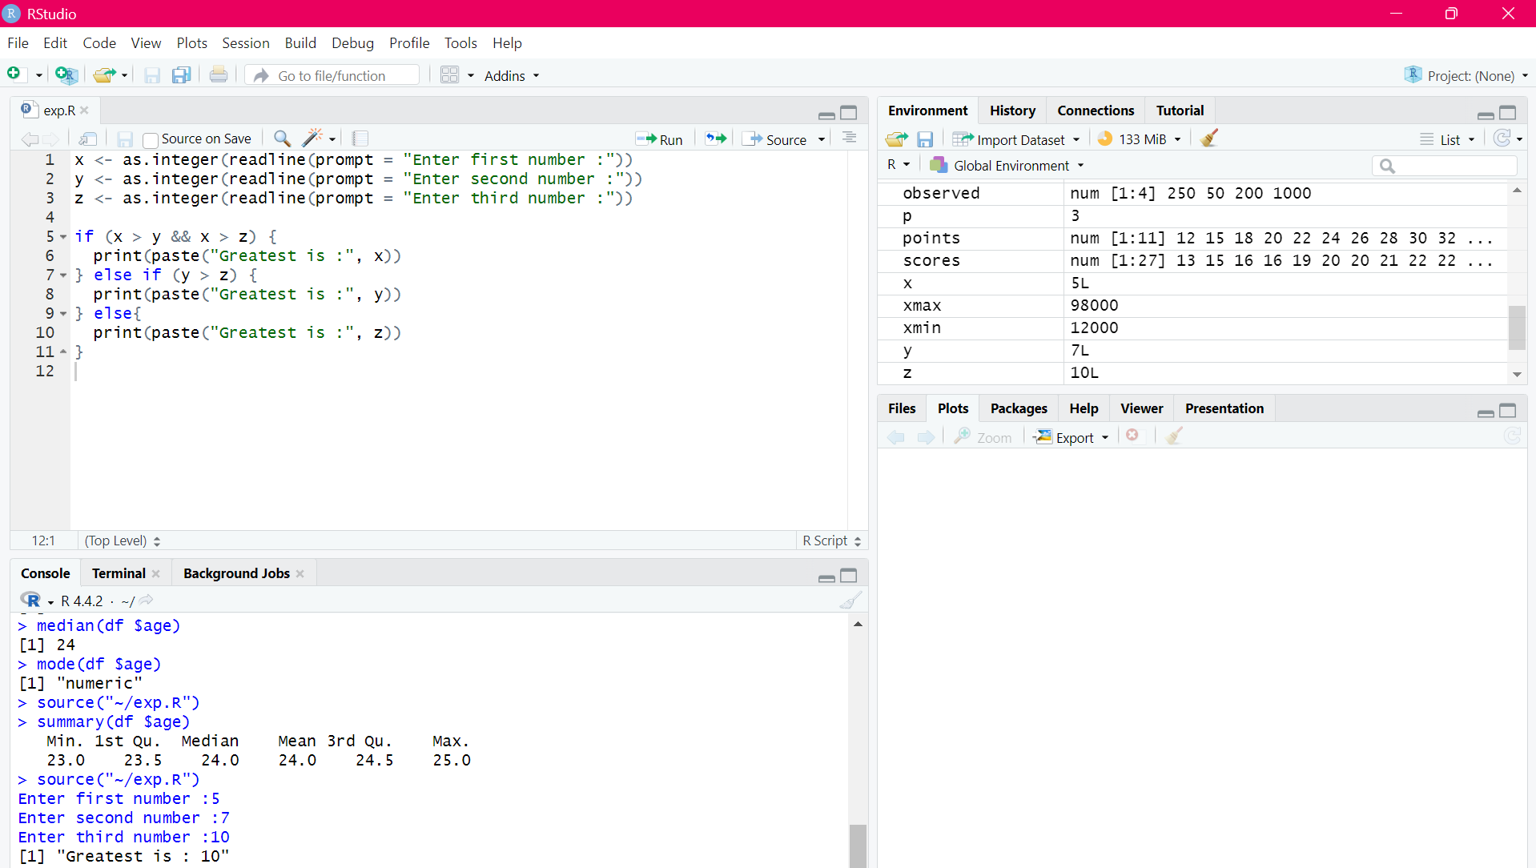
RESULT:
Thus, the greatest among the three numbers was executed successfully.

EXPERIMENT-9
IQR:
AIM:
To write the program for central tendency and data dispersion measures using R tool.
PROGRAM:
names<-c("siri","mahi","chiru")
age<-c(23,24,25)
marks<-c(88,78,25)
df<-data.frame(names,age,marks)
IQR(df $age)
write.csv(df,"datafr.csv")
OUTPUT:
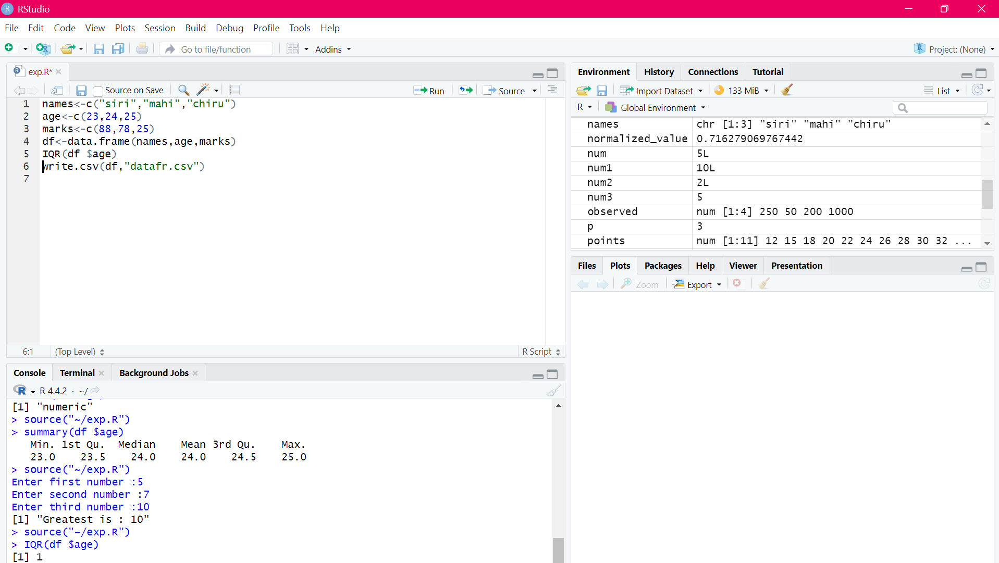
RESULT:
Thus, the program for central tendency and data dispersion measures was executed successfully.

EXPERIMENT-10
QUANTILE:
AIM:
To write the program for central tendency and data dispersion measures.
PROGRAM:
names<-c("siri","mahi","chiru")
age<-c(23,24,25)
marks<-c(88,78,25)
df<-data.frame(names,age,marks)
quantile(df $age)
write.csv(df,"datafr.csv")
OUTPUT:
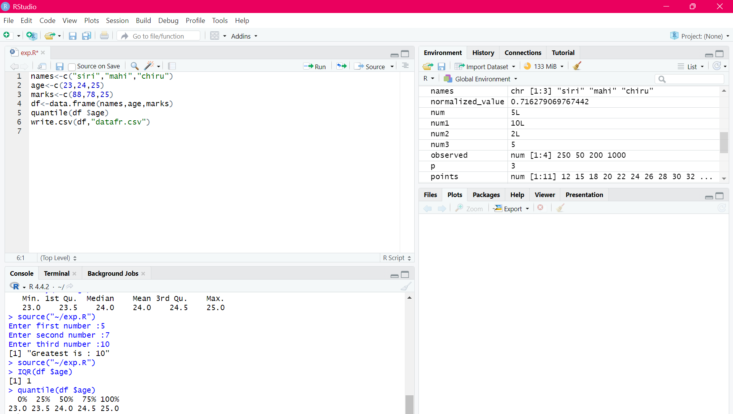
RESULT:
Thus, the program for central tendency and data dispersion measures was executed successfully

EXPERIMENT-11
MID RANGE:
AIM:
To write the program for central tendency and data dispersion measures.
PROGRAM:
names <- c("siri", "mahi", "chiru")
age <- c(23, 24, 25)
marks <- c(88, 78, 25)
df <- data.frame(names, age, marks)
midrange <- (min(df$age) + max(df$age)) / 2
print(midrange)
write.csv(df,"datafr.csv")
OUTPUT:
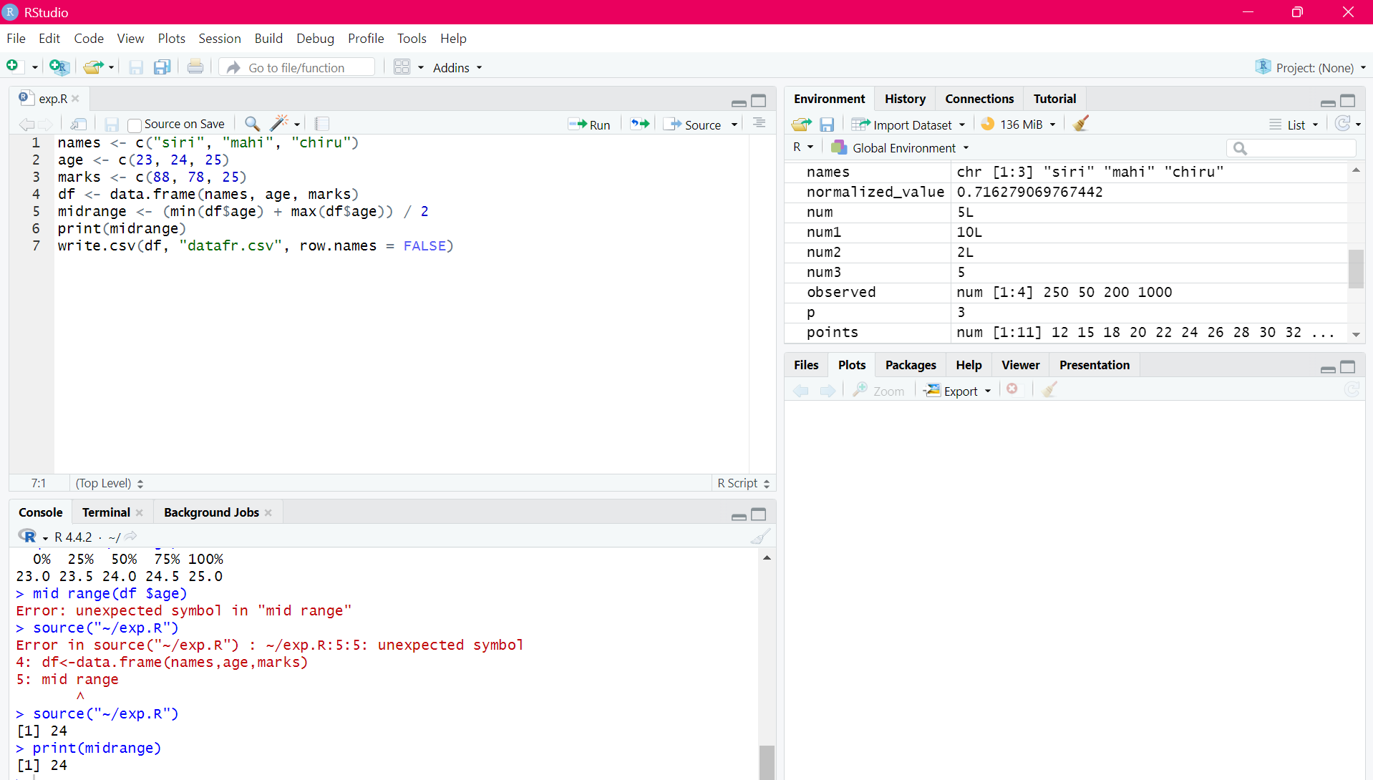
RESULT:
Thus, the program for central tendency and data dispersion measures was executed successfully

EXPERIMENT-12
Z-SCOORE NORMALIZATION:
AIM:
To write the program for Z-scoore normalization using R-tool.
PROGRAM:
library(readxl)
diabetest1<-read_excel("C:/Users/Viyaa/Downloads/diabdataset.xlsx")
A <- c(diabetest1$Age)
Mean <- mean(A)
Std <- sd(A)
Zscore <- (A - Mean) / Std
print(Zscore)

OUTPUT:
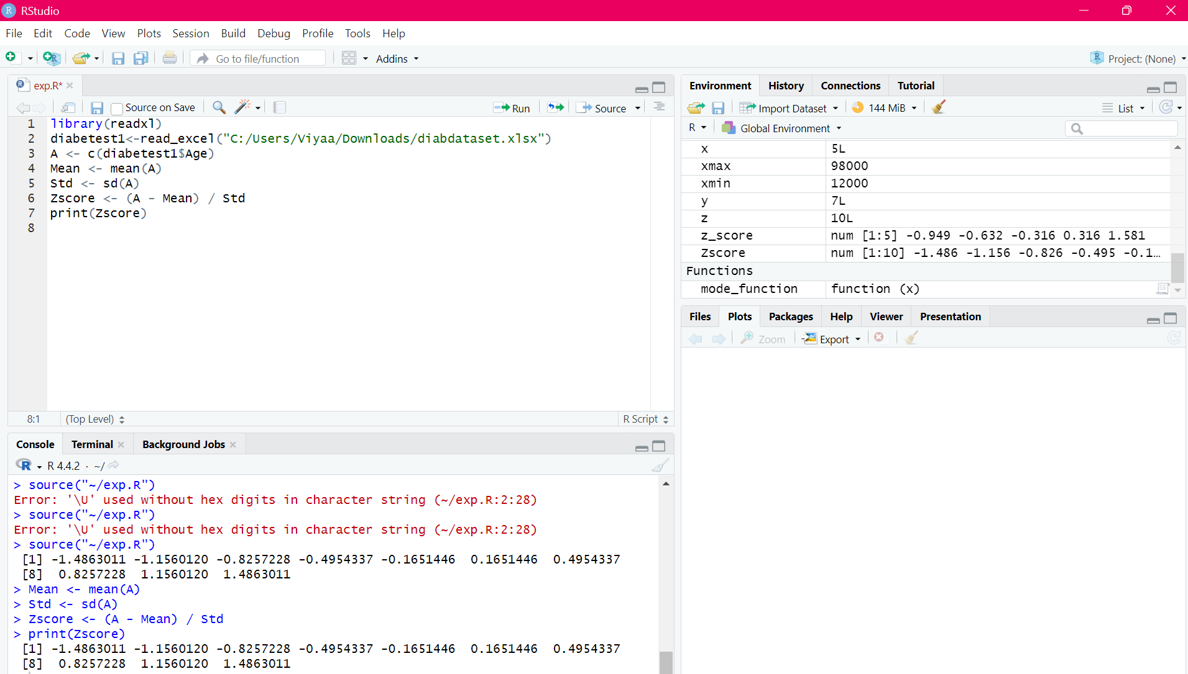

RESULT:
Thus, the Z-score normalization using R tool was executed successfully.

EXPERIMENT-13
MIN,MAX,MEAN,MINMAX:
AIM:

To write the program for the minimum,maximum,mean and minmax using r-TOOL

PROGRAM:
MEAN
library(readxl)
diabetest1<-read_excel("C:/Users/Viyaa/Downloads/diabdataset.xlsx")
A<-c(diabetest1$Age)
Mean<-mean(A)
print(Mean)
OUTPUT:
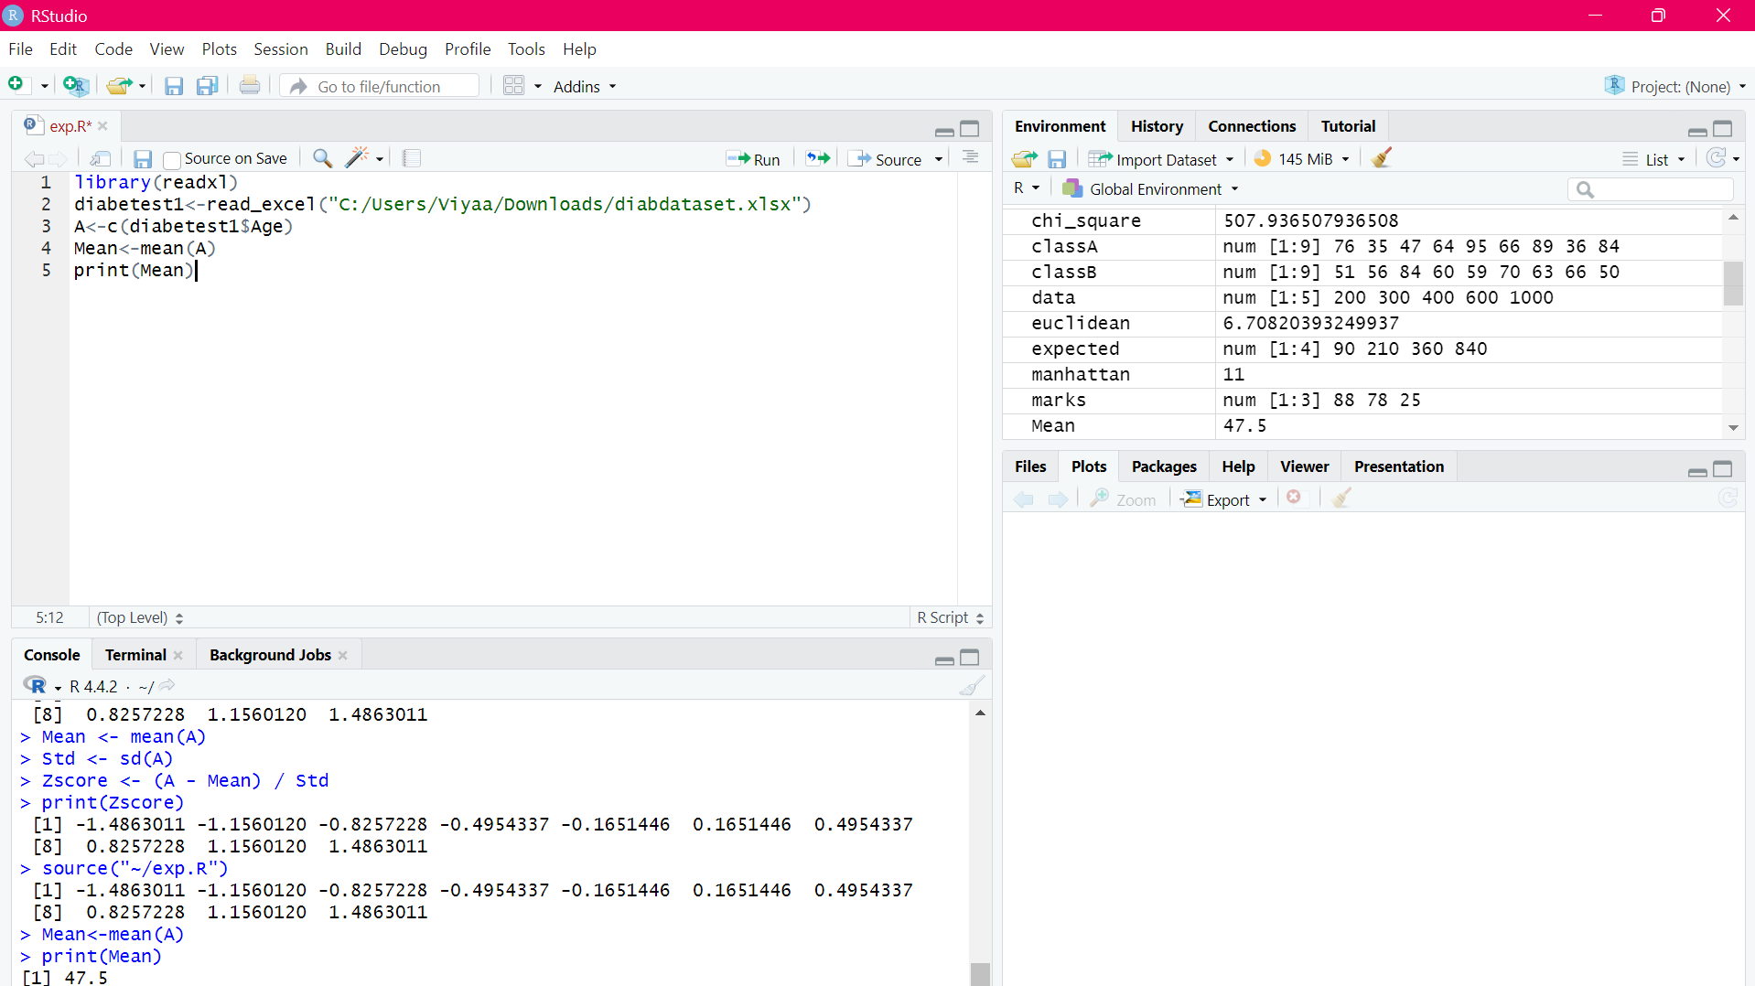
MINIMUM
library(readxl)
diabetest1<-read_excel("C:/Users/Viyaa/Downloads/diabdataset.xlsx")
A<-c(diabetest1$Age)
Minimum<-min(diabetest1$Age)
print(Minimum)OUTPUT:
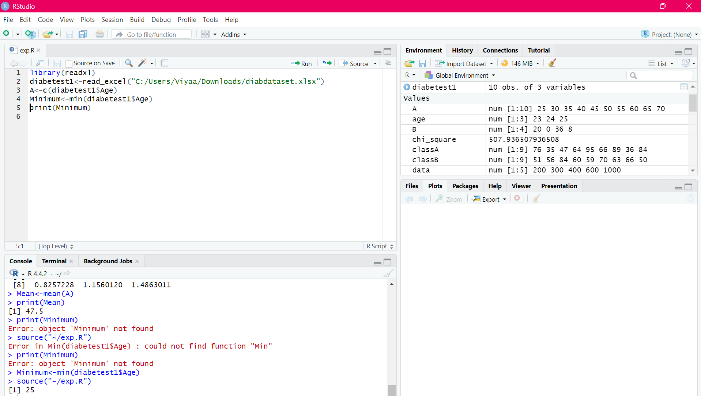
MAXIMUM
library(readxl)
diabetest1<-read_excel("C:/Users/Viyaa/Downloads/diabdataset.xlsx")
A<-c(diabetest1$Age)
Maximum<-max(diabetest1$Age)
print(Maximum)OUTPUT:
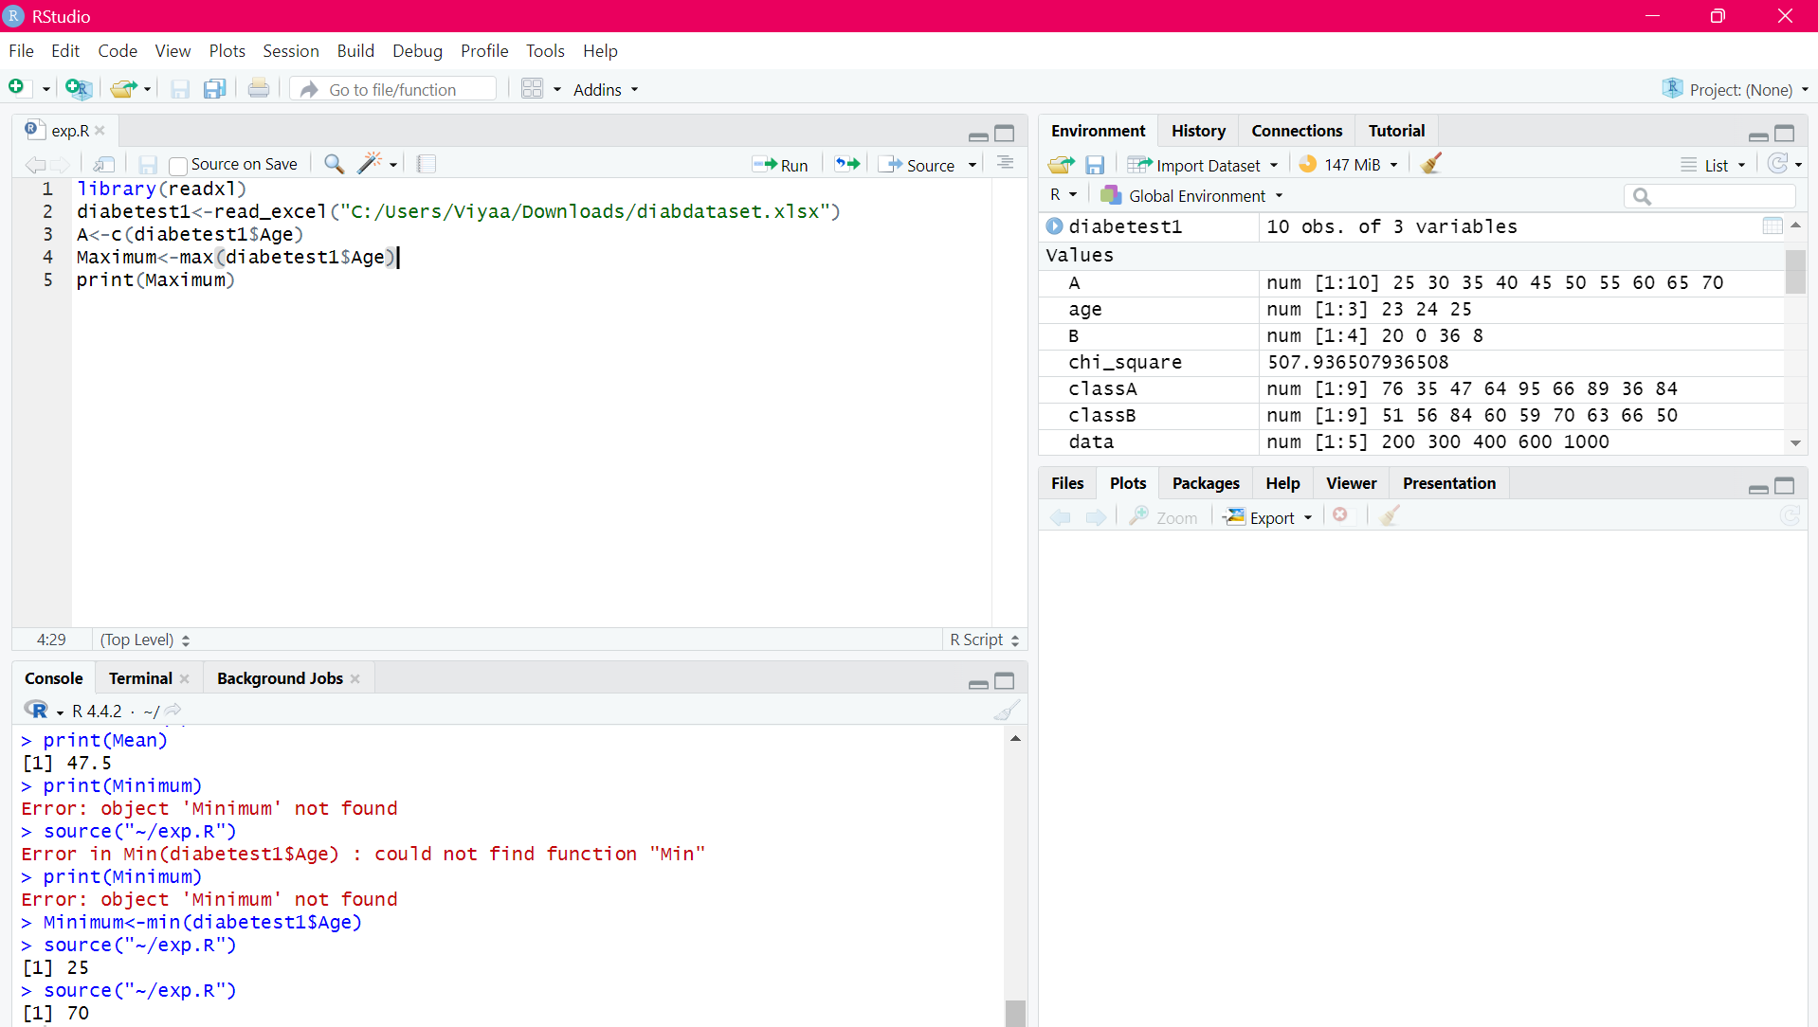

MINMAX
library(readxl)
diabetest1<-read_excel("C:/Users/Viyaa/Downloads/diabdataset.xlsx")
A<-c(diabetest1$Age)
Maximum<-Max(diabetest1$Age)
Minimum<-Min(diabetest1$Age)
MinMax<-(A-Minimum)/(Maximum-Minimum)
MinMax
OUTPUT:
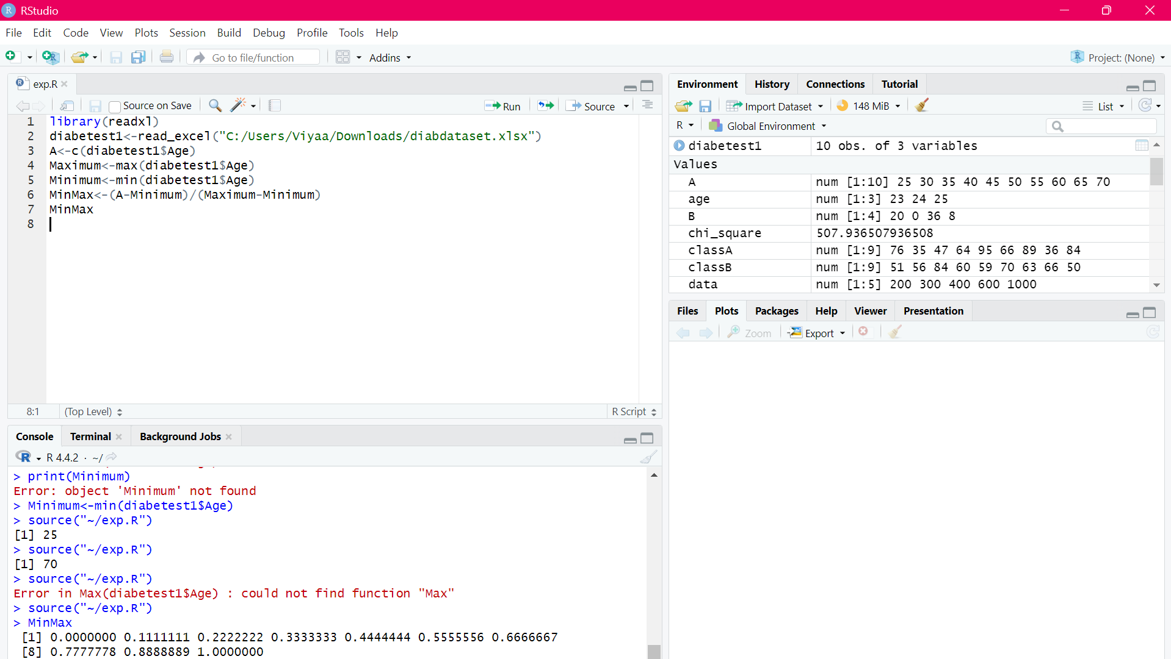
RESULT:
Thus, the program for min,max,minmax,mean was executed successfully.

EXPERIMENT-14
BAR PLOT AND HORIZONTAL BAR:
AIM:
To draw the bar plot and horizontal bar using R-tool.
PROGRAM:
a<-c(55,67,89,80,90)
barplot(a)
a<-c(55,67,89,80,90)
barplot(a)
barplot(a,horiz=TRUE)
OUTPUT:
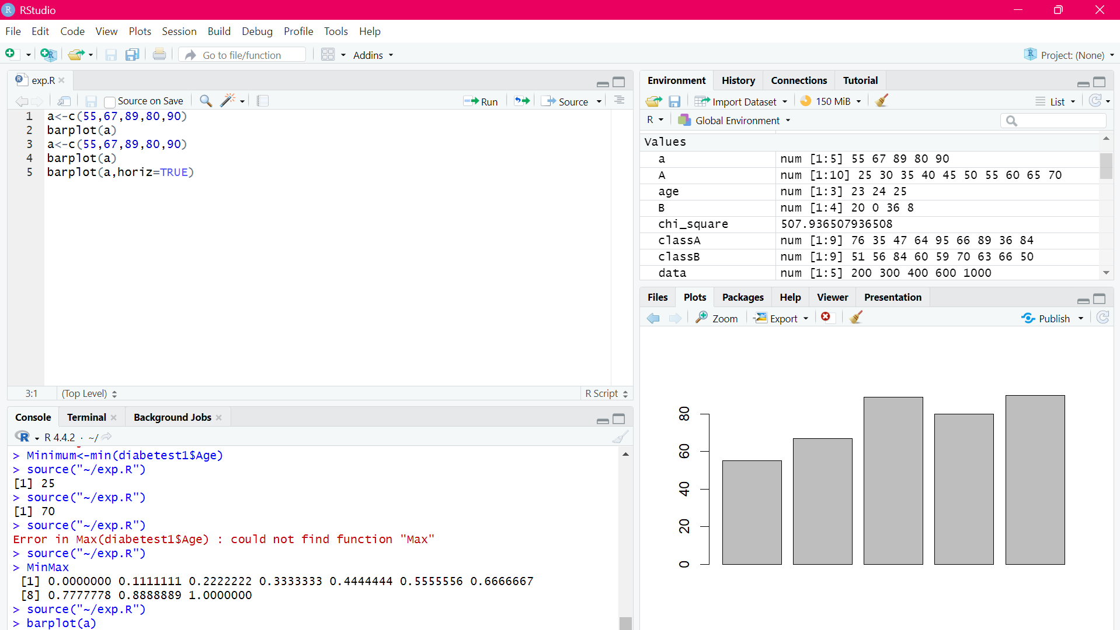

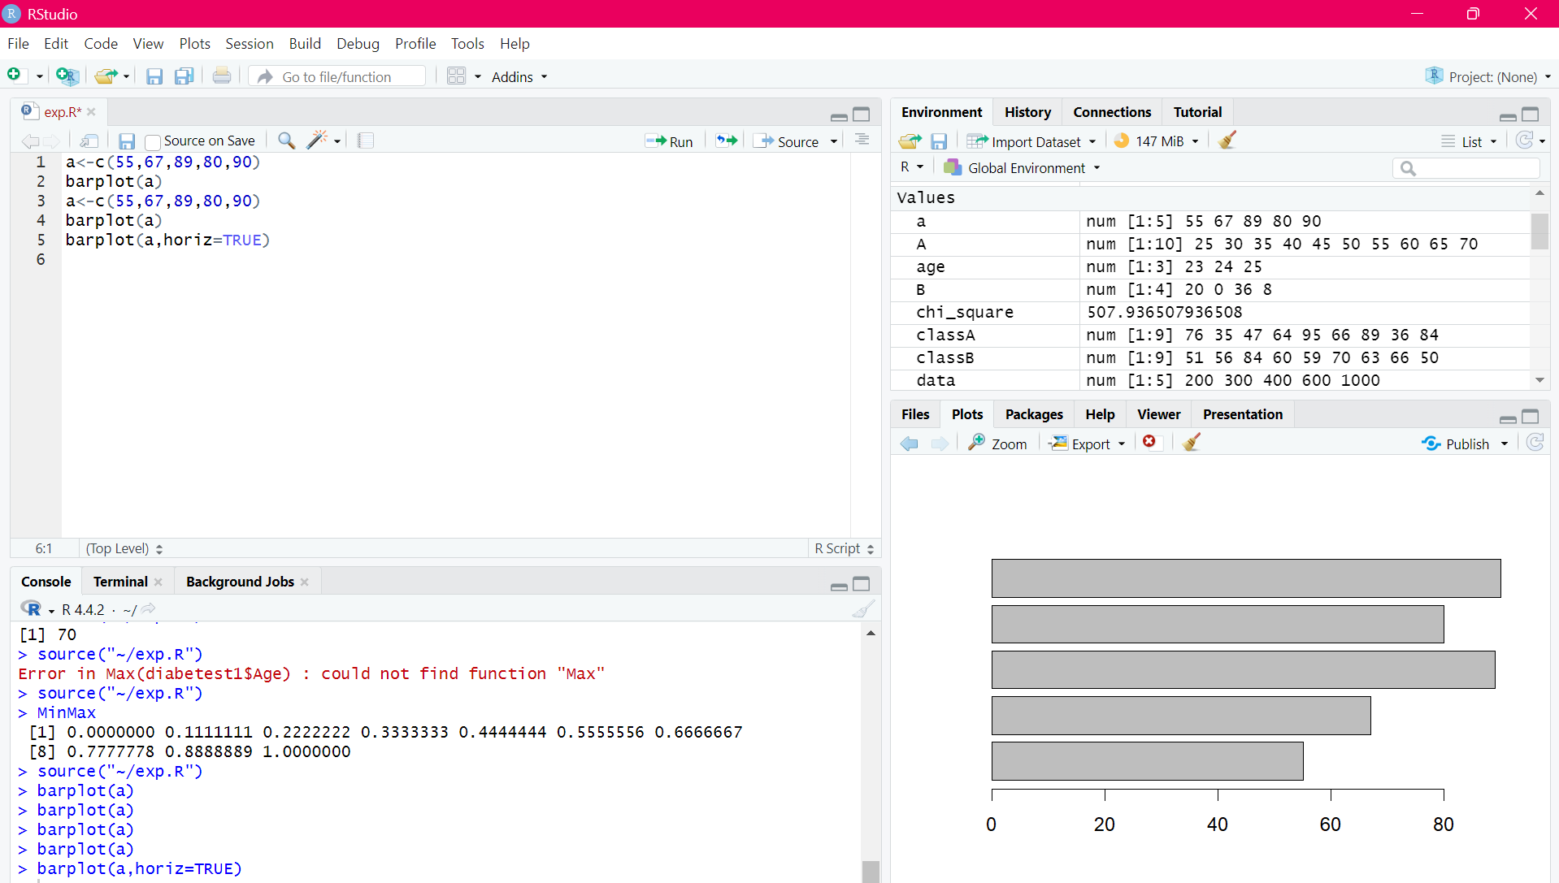
RESULT:
Thus, the bar and horizontal bar plot was executed successfully.

EXPERIMENT-15
BOX PLOT:
AIM:
To draw the box plot using R-tool.
PROGRAM:
names<-c("siri","chru","loki")
age<-c(23,24,25)
marks<-c(88,78,25)
df<-data.frame(names,age,marks)
hist(df$age)
boxplot(df$age)
OUTPUT:
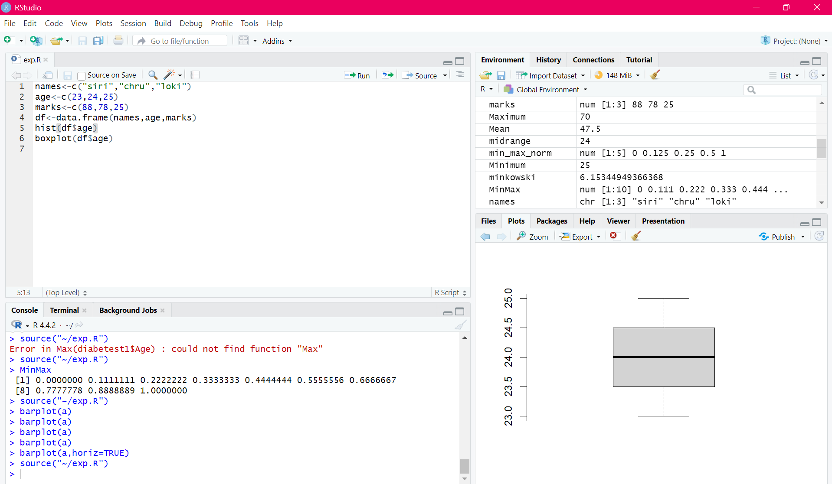
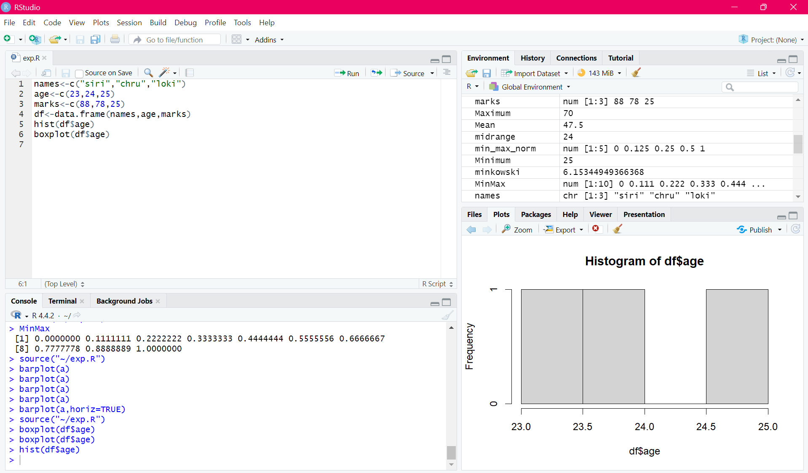
RESULT:
Thus, the box plot was executed successfully.

EXPERIMENT-16
HISTOGRAM:
AIM:
To draw the histogram plot using R-tooll.
PROGRAM:
a<-c(55,67,89,80,90)
hist(a)
OUTPUT:
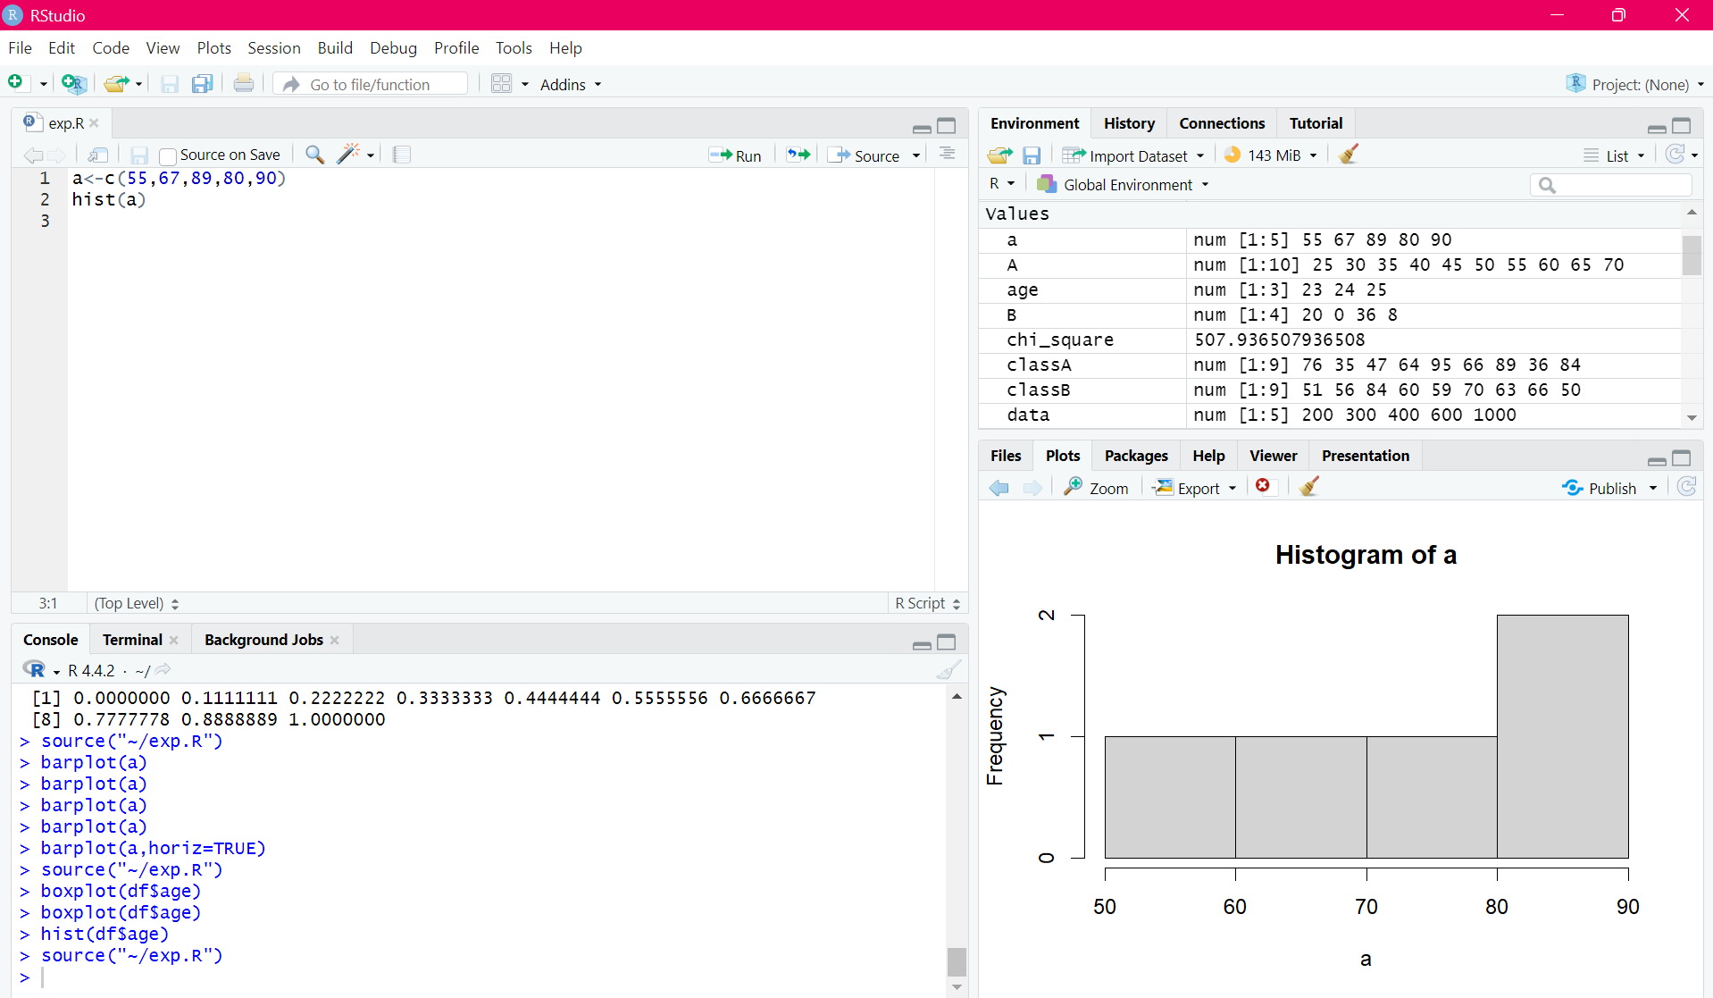

RESULT:
Thus, the histogram plot was executed successfully.

EXPERIMENT-17
CORRELATION ANALYSIS:
AIM:
To write the program for correlation analysis using R-tool.
PROGRAM:
library(readxl)
diabetest1<-read_excel("C:/Users/Viyaa/Downloads/diabetesdataset.xlsx")
diabetest1 <- table(diabetest1$Age, diabetest1$Insulin)
print(diabetest1)
chisq.test(diabetest1)
OUTPUT:
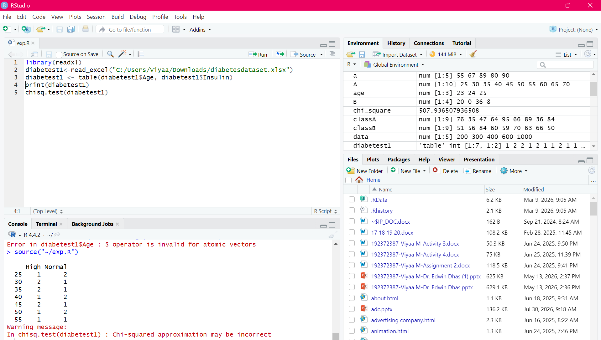
RESULT:
Thus, the correlation analysis was executed successfully.

EXPERIMENT-18
SCATTER PLOT:
AIM:
To draw the scatter plot using R-tool
PROGRAM:
set.seed(9)
x <- rnorm(1000)
y <- rnorm(1000)
smoothScatter(y - x)
smoothScatter(x,y)
OUTPUT:
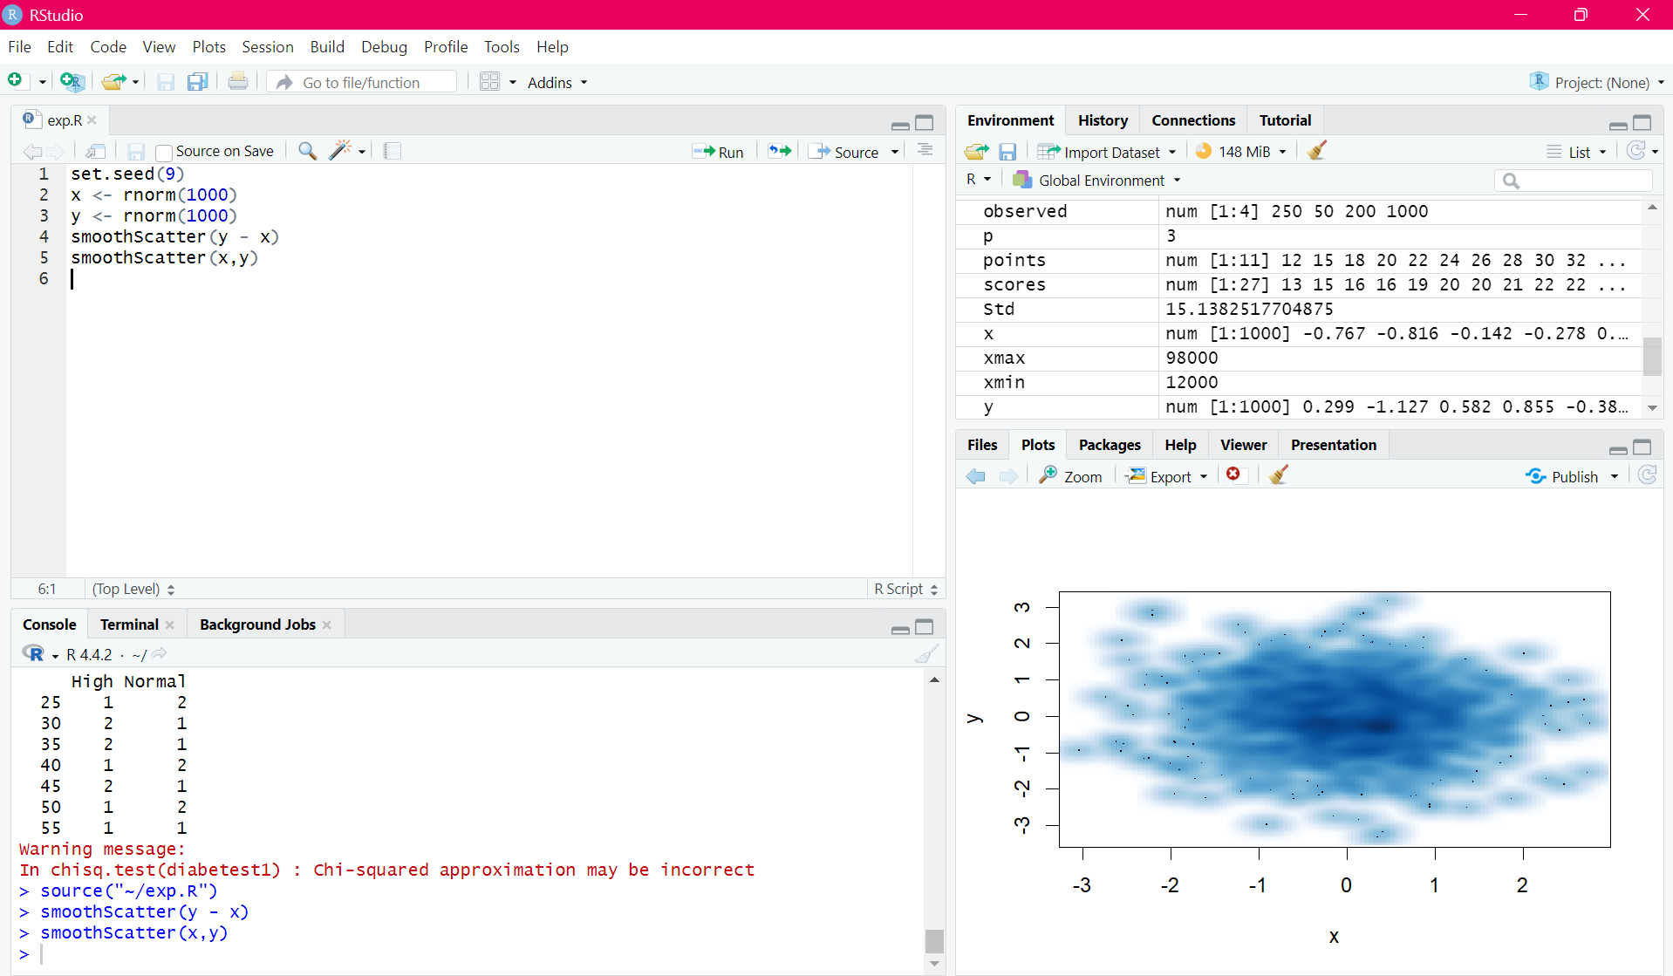

RESULT:
Thus, the scatter plot was executed successfully.

EXPERIMENT-19
LINEAR REGRESSION:
AIM:
To write thr program for the linear regression using R-tool.
PROGRAM:
library(readxl)
diabetes <- read_excel("C:/Users/Viyaa/Downloads/diabdataset.xlsx")
Relation <- lm(BloodPressure ~ Age, data = diabetes)
png("linear_regression.png")
plot(diabetes$Age, diabetes$BloodPressure,
col = "purple",
main = "Linear Regression Analysis",
xlab = "Age",
ylab = "Blood Pressure")
abline(Relation, col = "pink", lwd = 2)
dev.off()
print(summary(Relation))OUTPUT:
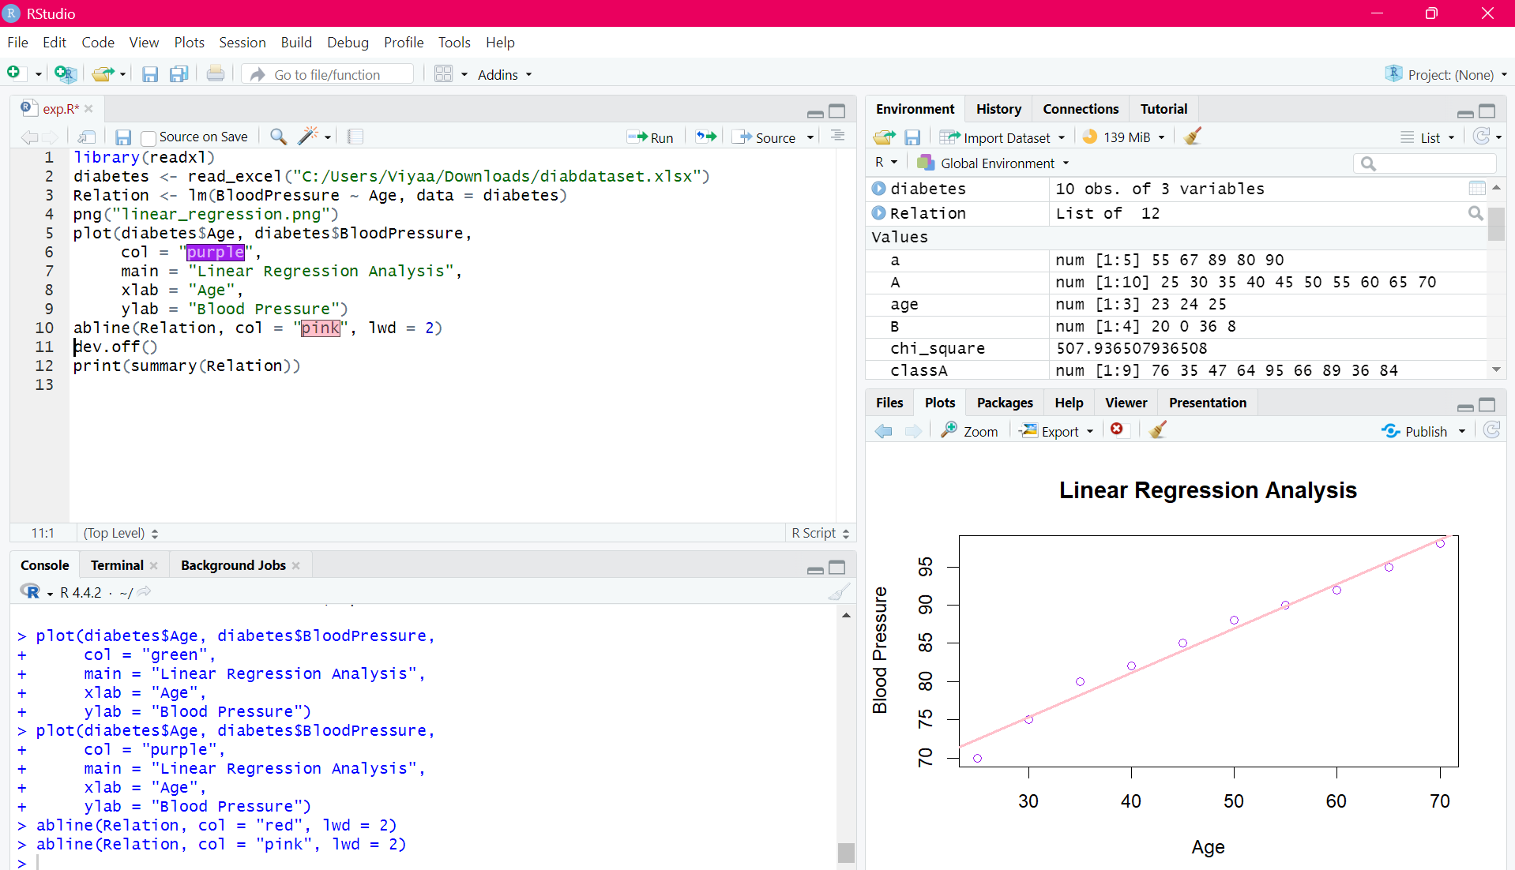

RESULT:
Thus, the linear regression program was executed successfully.

EXPERIMENT-20
MULTIPLE REGRESSION:
AIM:
To write the program for the multiple regression.
PROGRAM:
library(readxl)
diabetes <- read_excel("C:/Users/Viyaa/Downloads/diabdataset.xlsx")
input <- diabetes[, c("Age", "BloodPressure", "Glucose")]
model <- lm(Age ~ BloodPressure + Glucose, data = input)
print(model)
A <- coef(model)[1]
print(A)
xBloodPressure <- coef(model)[2]
yGlucose <- coef(model)[3]
print(xBloodPressure)
print(yGlucose)
y <- paste("Age =", A, "+", xBloodPressure,
"* BloodPressure +", yGlucose, "* Glucose")
print(y)OUTPUT:
